**Front End Engineering**

Project Report

Semester-IV (Batch-2022)

**DOUBLE VERTICAL SLIDER**

**Supervised By: Submitted By:**

Raveesh Samkaria Yashasvi Nag

(2210990975)

**Department of Computer Science and Engineering,** Chitkara University Institute of Engineering & Technology

**ABSTRACT**

This project report provides a comprehensive overview of the development process undertaken to create a web-based interactive feature termed the Double Vertical Slider, leveraging the capabilities of Tailwind CSS. The Double Vertical Slider aims to revolutionize user engagement by facilitating simultaneous navigation through paired content arranged vertically. Through meticulous planning and execution, the project endeavors to achieve several objectives, including the creation of an intuitive and responsive slider interface, while upholding principles of code cleanliness and maintainability. The significance of this endeavor lies in its potential to significantly enhance user experience on websites grappling with spatial constraints for content presentation. By allowing users to seamlessly interact with paired content in a vertical orientation, the Double Vertical Slider seeks to transcend traditional limitations of horizontal sliders and offer a novel and engaging browsing experience. The report meticulously delineates the project's background, objectives, and significance, delving into the intricacies of the problem statement, software requirements, and the proposed design methodology. Furthermore, the report provides a detailed account of the achieved results, accompanied by screenshots and metrics, showcasing the efficacy and versatility of the implemented Double Vertical Slider. Through rigorous testing and refinement, the project demonstrates its capacity to meet user expectations and elevate the standards of user interface design in contemporary web development practices.

**TABLE OF CONTENTS**

|  |  |  |
| --- | --- | --- |
| **S.NO.** | **CONTENT** | **PAGE NO.** |
| 1. | [Introduction](https://chat.openai.com/c/d587e11c-9e0c-4c16-aea7-86f64756becf#1-introduction)   * 1. Background   2. Objectives   3. Significance | 4 |
| 2. | Problem Definition and Requirements   * 1. Problem Statement   2. Software Requirements | 5 |
| 3. | Proposed Design/ Methodology   * 1. Schematic Diagram   2. File Structure | 6 |
| 4. | Result   * 1. Code Snippets   2. Screenshots | 7-11 |
| 5. | References | 12 |

1. **INTRODUCTION**
   1. **BACKGROUND**

The use of sliders in web design has been a popular element to enhance user interactivity and engagement. Traditional sliders are horizontal and allow users to view content such as images, text, or videos by sliding left or right. The idea of a double vertical slider is an innovative approach that aims to utilize vertical screen real estate more effectively, allowing users to interact with two segments of content simultaneously.

* 1. **OBJECTIVE**

The primary objectives of this project include:

* To design a user-friendly vertical slider using Tailwind CSS.
* To ensure the slider is responsive and functions seamlessly across different devices and screen sizes.
* To implement a clean and maintainable codebase using modern development practices.
  1. **SIGNIFICANCE**

The significance of this project lies in its potential to enhance user experience on websites where heavy content needs to be displayed in a limited space. By using a vertical slider, more content can be presented in an engaging and interactive manner, improving navigation and aesthetic appeal.

1. **PROBLEM DEFINITION AND REQUIREMENTS**
   1. **PROBLEM STATEMENT**

The main challenge is to design a double vertical slider that is both efficient in space usage and intuitive for end-users. The slider must synchronize the movement of two content panels while ensuring smooth transitions and compatibility with various browsers and devices.

* 1. **SOFTWARE REQUIREMENT**

Tailwind CSS: For styling and responsive design.

HTML:For structuring the web components.

Javascript: For slider functionality and interactions.

Development Environment: Any code editor (e.g., VSCode, Sublime Text)

1. **PROPOSED METHODOLOGY**
   1. **SCHEMATIC DIAGRAM**

The schematic diagram for the Double Vertical Slider illustrates the structural components and the interaction flow within the system. It depicts the layout of the slider interface, including the arrangement of paired content panels and the controls for navigation. The diagram showcases the alignment and positioning of elements, such as buttons or indicators, used to facilitate user interaction. Additionally, it highlights the underlying logic and algorithms governing the behavior of the slider, particularly in synchronizing the movement of the content panels and ensuring smooth transitions between states. Overall, the schematic diagram provides a visual blueprint of the Double Vertical Slider's architecture, offering insights into its functionality and design rationale.

* 1. **FILE STRUCTURE**

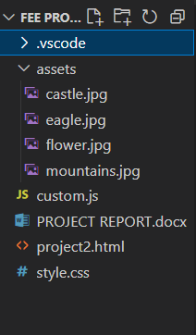

1. **RESULT**
   1. **CODE SNIPPET**

HTML CODE:

<!DOCTYPE html>

<html lang="en">

<head>

    <meta charset="UTF-8">

    <meta name="viewport" content="width=device-width, initial-scale=1.0">

    <title>Double Vertical Slider</title>

    <link href="https://cdnjs.cloudflare.com/ajax/libs/tailwindcss/2.2.19/tailwind.min.css" rel="stylesheet">

    <link rel="stylesheet" href="https://cdnjs.cloudflare.com/ajax/libs/font-awesome/5.15.1/css/all.min.css" />

    <link rel="stylesheet" href="style.css">

</head>

<body class="font-sans h-screen">

    <div class="slider-container flex">

        <!-- Left Slide with Positioned Slides -->

        <div class="left-slide relative w-1/3" style="transition: transform 0.5s ease-in-out; height: 400%;">

            <div class="h-1/4 w-full flex flex-col justify-center items-center text-white" style="background-color: #f40a23;">

                <h1 class="text-4xl">Nature Flower</h1>

                <p>all in pink</p>

            </div>

            <div class="h-1/4 w-full flex flex-col justify-center items-center" style="background-color: #2A86BA;">

                <h1 class="text-4xl">Bluuue Sky</h1>

                <p>with its mountains</p>

            </div>

            <div class="h-1/4 w-full flex flex-col justify-center items-center" style="background-color: #252E33;">

                <h1 class="text-4xl">Lonely Castle</h1>

                <p>in the wilderness</p>

            </div>

            <div class="h-1/4 w-full flex flex-col justify-center items-center" style="background-color: #a82f02;">

                <h1 class="text-4xl">Flying Eagle</h1>

                <p>in the sunset</p>

            </div>

        </div>

        <!-- Right Slide with Positioned Slides -->

        <div class="right-slide relative w-2/3" style="transition: transform 0.5s ease-in-out; height: 400%;">

            <div class="h-1/4 w-full bg-cover" style="background-image: url('assets/eagle.jpg');"></div>

            <div class="h-1/4 w-full bg-cover" style="background-image: url('assets/castle.jpg');"></div>

            <div class="h-1/4 w-full bg-cover" style="background-image: url('assets/mountains.jpg');"></div>

            <div class="h-1/4 w-full bg-cover" style="background-image: url('assets/flower.jpg');"></div>

        </div>

        <!-- Action Buttons -->

        <div class="action-buttons flex flex-col space-y-2 justify-start absolute" style="left:33.2%">

            <button class="down-button bg-white hover:bg-gray-300 p-3" onclick="changeSlide('down')">

                <i class="fas fa-arrow-down"></i>

            </button>

            <button class="up-button bg-white hover:bg-gray-300 p-3 relative" style="right: 91%;" onclick="changeSlide('up')">

                <i class="fas fa-arrow-up"></i>

            </button>

        </div>

    </div>

    <script src="custom.js"></script>

</body>

</html>

CSS CODE:

body {

    height: 100vh;

  }

  .slider-container {

    position: relative;

    overflow: hidden;

    height: 100vh;

    width: 100vw;

  }

  .action-buttons {

    position: absolute;

    z-index: 100;

    left: 35%;

    top: 50%;

    transform: translateY(-50%);

    display: flex;

    flex-direction: column;

  }

  .down-button {

    transform: translateX(-100%);

    border-top-left-radius: 5px;

    border-bottom-left-radius: 5px;

  }

  .up-button {

    transform: translateX(100%);

    border-top-right-radius: 5px;

    border-bottom-right-radius: 5px;

  }

JAVASCRIPT CODE:

const sliderContainer = document.querySelector('.slider-container');

        const slideRight = document.querySelector('.right-slide');

        const slideLeft = document.querySelector('.left-slide');

        const slidesLength = slideRight.querySelectorAll('div').length;

        let activeSlideIndex = 0;

        slideLeft.style.top = `-${(slidesLength - 1) * 100}vh`;

        const changeSlide = (direction) => {

            const sliderHeight = sliderContainer.clientHeight;

            if (direction === 'up') {

                activeSlideIndex--;

                if (activeSlideIndex < 0) {

                    activeSlideIndex = slidesLength - 1;

                }

            } else {

                activeSlideIndex++;

                if (activeSlideIndex >= slidesLength) {

                    activeSlideIndex = 0;

                }

            }

            slideRight.style.transform = `translateY(-${activeSlideIndex * sliderHeight}px)`;

            slideLeft.style.transform = `translateY(${activeSlideIndex * sliderHeight}px)`;

        };

* 1. **SCREENSHOTS**

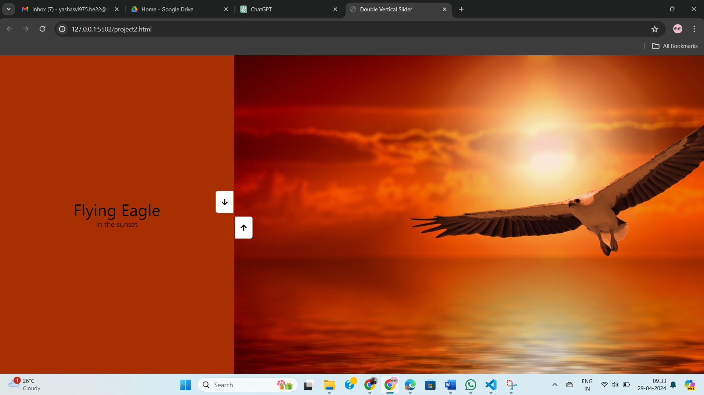

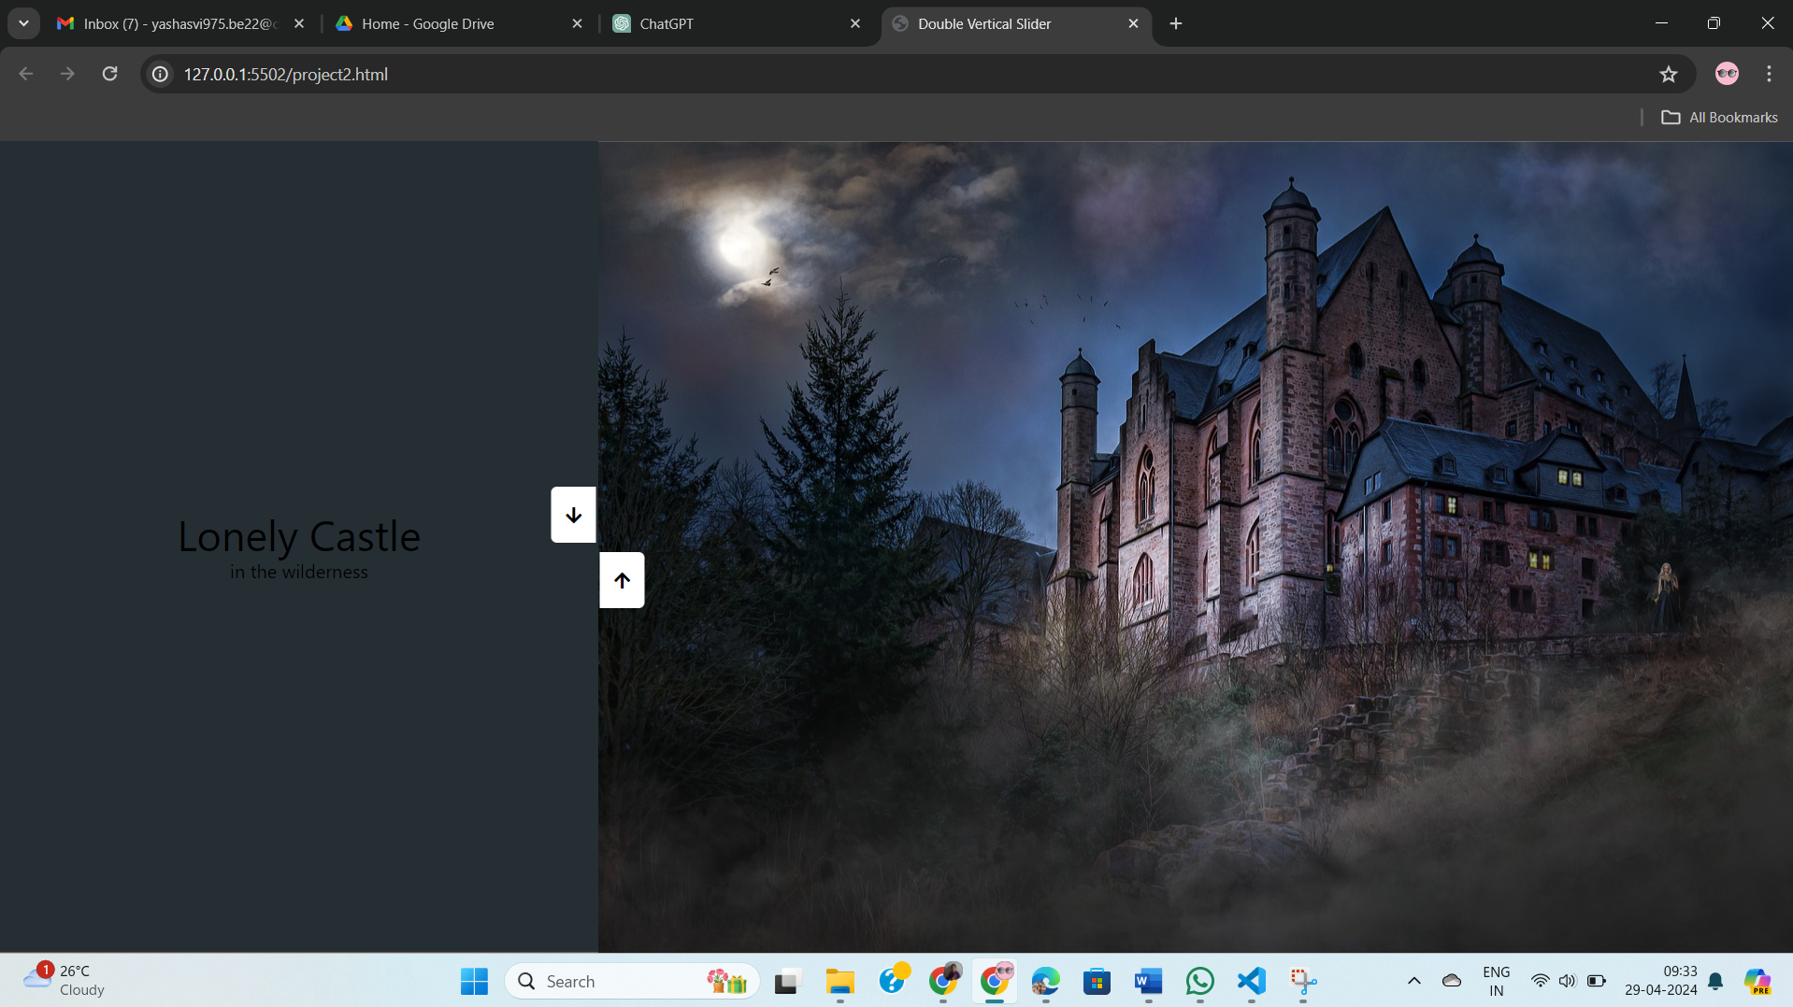

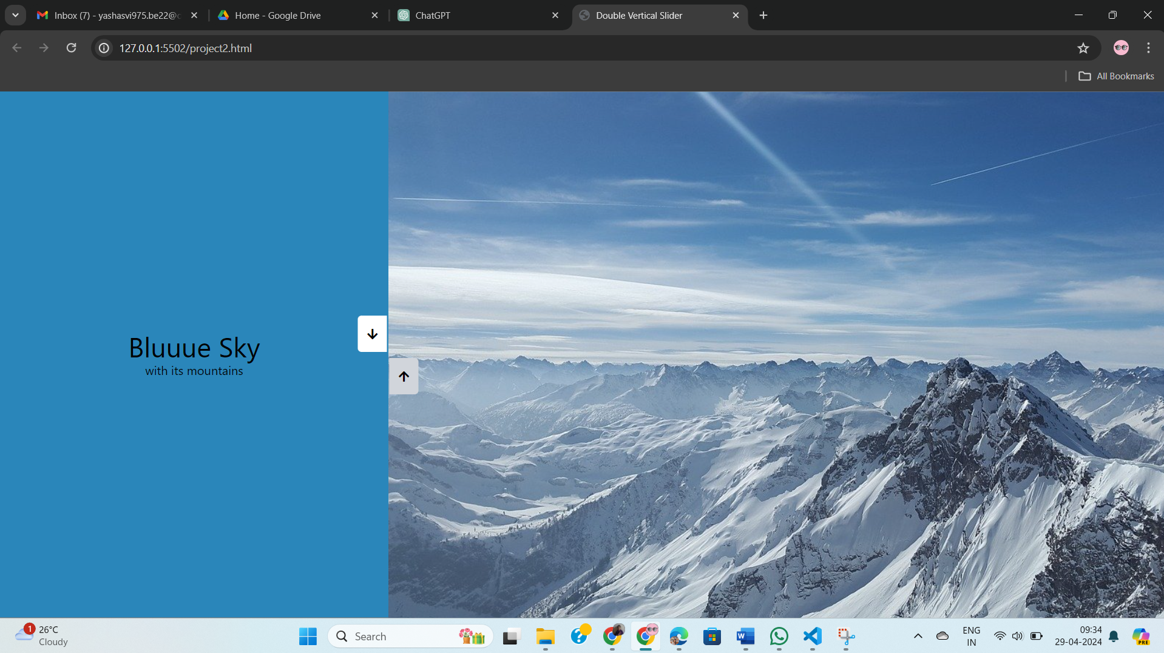

1. **REFERENCES**

* Tailwind CSS Documentation. The version imported in this code is 2.2.19.

Source: <https://tailwindcss.com/>

["https://cdn.tailwindcss.com?plugins=forms,typography,aspect-ratio,line-clamp,container-queries"](https://cdn.tailwindcss.com?plugins=forms,typography,aspect-ratio,line-clamp,container-queries)

* Youtube Tutorial of Double Vertical Slider: <https://www.youtube.com/watch?v=ULCbTMl6q9U&t=38s>